**Lab 7**

**Ee330**

**Introduction**

In this lab, we are going to use most transistor to develop methods for measuring key parameters of the transistor, and to investigate some basic applications of the device.

**Part 1. Set up Signal Express**

In this part we are going to use signal express to do most of our testing.

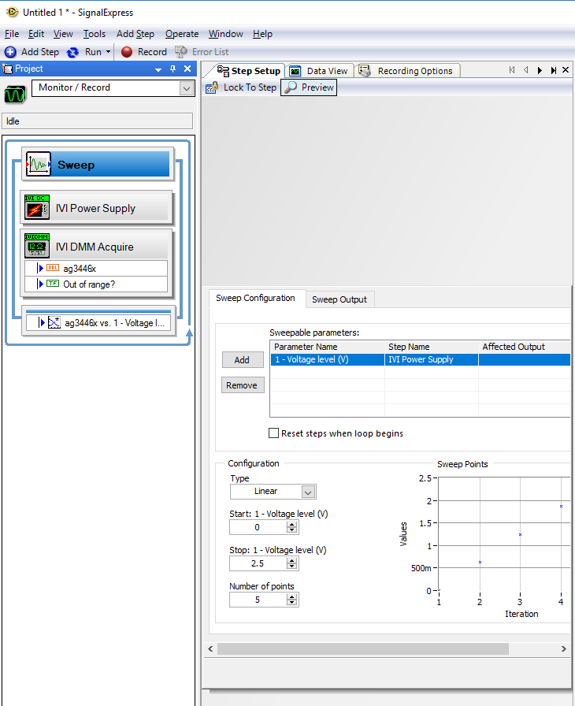

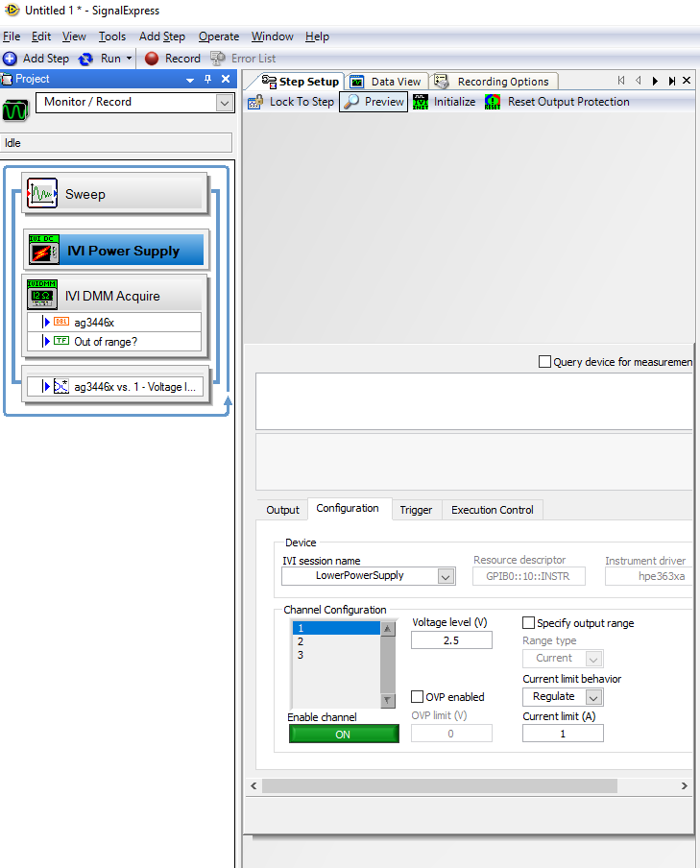

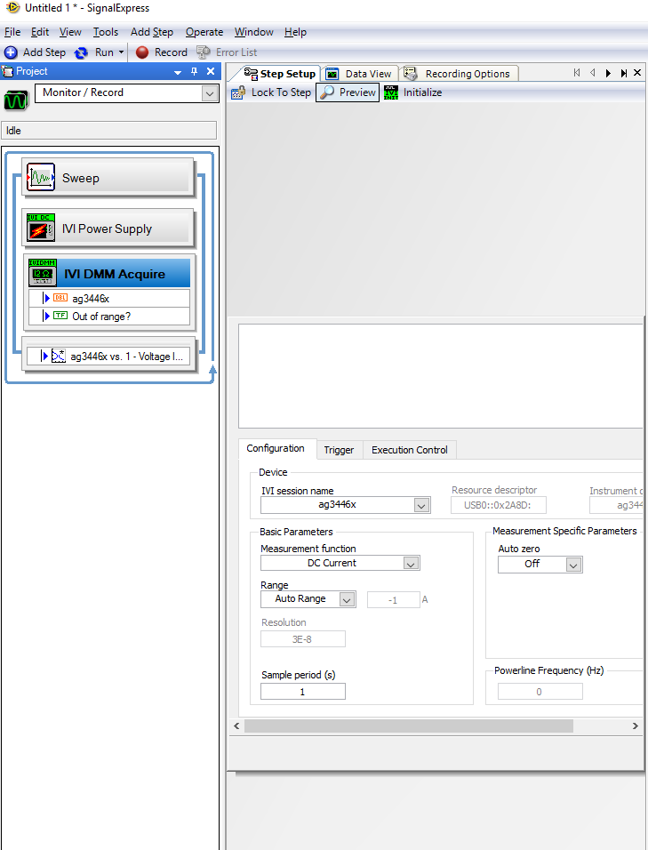

**Part 2**

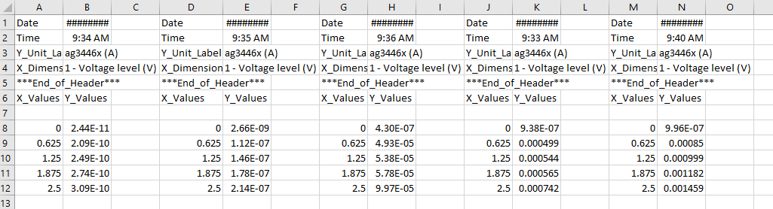

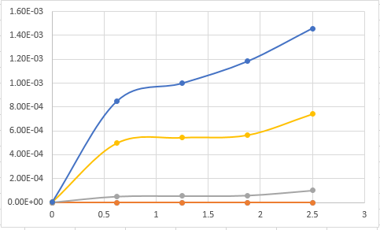

Solving for UCox

Slope= 

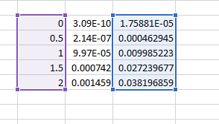

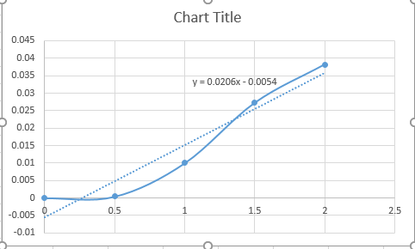

Slope= 0.0206

Now we can easily solve for UCox